Chapter 3
The Proposed System

3.1 Case Study
The prime reason for the introduction of challan automation system is to minimize the amount of resources being used for the current system. This process only addresses few of the issues that are causing to register a challan to take more than 24 hours. Even after 24 hours an individual challan receipt is not recorded at all the locations where it is needed. To do so, it takes more than 2 days.
The cycle of the challan process starts when a road user commits a traffic rule violation and is apprehended by the sergeant or traffic warden, (refer to Table 2.1 for the types of violations). Upon the apprehension, the driver is asked to show the driving license and the registration book of the vehicle for the personal vehicle and route permit for the commercial usage vehicles. Keeping these documents along with the Computerized National Identity Card (CNIC) at all times is necessary in Pakistan’s law as they can be asked by any duty officer from the driver while using the road.
3.1.1 The Current Challan Recording Process
Once the offender is found guilty, he/she is fined according to the prescribed penalties. The duty officer records the violations, offender’s information, vehicle’s information and the place of violation on the challan book issued to him. Upon completion, he hands over 2 copies to the offender and keeps the remaining 3 copies with him.
At this stage this process divides into two parts. At one side the offender is bound to pay the penalty amount at any National Bank branch in the city. The bank keeps one copy for the record and gives back the other copy to receive the confiscated document back from the designated Zone office within 14 days of the challan date. Failing to do so the confiscated documented is sent to city law court for further processing and legal work. While on the other hand, the duty officer has to submit the confiscated document and 1 challan receipt at the Zone office from where offender will collect it, and submit the remaining 2 copies at the main traffic police office where they are distributed at the record room an the IT section for record keeping.
All this process takes at least 2 days to complete while the record of this may take 2 to 3 more days to be available for reporting and/or other purposes, while any other law enforcing organization has no connection to use this information in any sort of enquiries. They have to formally ask the traffic police department for any concerned queries which may take some time to be analyzed and verified, as the computer based record is currently being maintained on MS Excel Sheets.
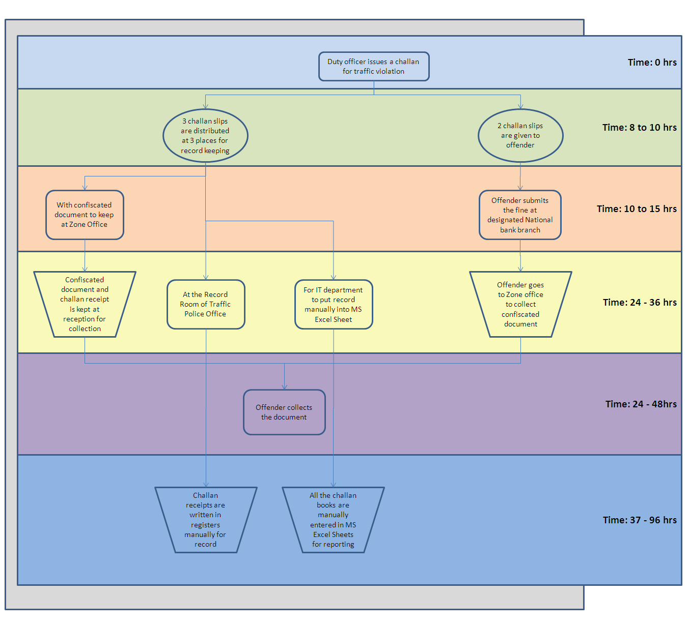
Below is the process diagram for the current challan recording system.
Figure 3.1: The Current Challan Recording Process
3.2 The Key Points for Improvement
The main points that are considered while designing and developing the system mainly concern to minimize the resource usage, specially the time, and provide Islamabad Traffic Police (ITP) with centralized, reliable and accurate information that can be accessed anything through local and/or internet web servers. Following features were kept in mind;
- To provide ITP with a centralized system that can be updated anytime.
- To make an easy to use system that is based upon the current system so that the migration cost is as low as possible
- To minimize the time required to process and record daily challan so that reporting is accurate and fast
- To make a user role based system to ensure data integrity, transparence and security.

3.3 The Proposed System
The proposed system can be considered as a prototype for the initial phase of the challan automation system. Based upon a through analysis of the on-going manual system, the new system encompasses the issues regarding;
- The quick update of the challan records
- Cut down in the time to replicate the record to the concerned authorities
- Ease in different types of individual as well as trend reporting
- Flexibility of the organizational structure and customization
- Minimize the possibility of error and data redundancy
- Easy to use and update web based system that is secure and efficient
It is currently a process based system that has automated the current system, without giving any sorts of improvements and or suggestions to make it more efficient.
ITP challan automation system is mostly a post activity bases system. This means that the actual on-ground activity has taken place an the users of the system are only recording that activity so that the data is maintained at a central location and may be used at any time for better resource allocation, improved future planning and insightful pattern analysis for the times to come.
3.3.1 Challan Activity
As soon as the duty officer completes his duty on the site, he will be going to the Zone office for the usual trip to submit the challans and the confiscated documents but that this time. At this time there can be alternate ways to put in the daily data into the system, either this task can be given to the sergeant or anybody at the zone office, but the daily data is to be updated after the end of every shift so that current system’s status is always up-to-date.
3.3.2 Record Keeping and Updating
As the data is updated at the zone office level, there will be no need to put in the data for record keeping and no extra effort will the needed for the system’s updating. This is the point where most of the process time is cut down.
3.3.3 BankTrancastion
Whenever the offender or his/her representative goes to the bank for the submission of the penalty, the banker will login to the system using a special account that will give him the access to only the Deposit module where he can put in the book and challan number to locate the exact challan and set it’s status to “paid”.
This will help the police department in many ways;
- One the status of the challan will be tracked and secondly the actual values in the report will show the exact status of the whole challan process.
- Secondly the defaulters can be identified easily and can be dealt with.

3.3.4 Zone Office (document collection point)
As the system is totally updated on the challan status, the duty personal at the document collection point will have all the information of every challan helping him to easily catalog the documents and keep track of the pending and the taken away documents.
This process can minimize the time to less than 4 to 5 hours job helping the police department, the road users and the banks to work efficiently and vigilantly.

